**Standards**

**Protocol:**

A **protocol** is a standard set of rules that allow electronic devices to communicate with each other.

There are two imp types of communication protocols are used in cloud computing for accessing cloud data from client machine and vice versa.

**COMMUNICATION PROTOCALS : HTTP and XMPP**

**HTTP :**

Hypertext Transfer Protocol

Usage: for accessing cloud data from client machine and vice versa.

HTTP is a stateless protocol.

A stateless protocol does not require the server to retain information or status about each user for the duration of multiple requests.

HTTP/1.0 uses a new connection for each request/response exchange, where as HTTP/1.1 connection may be used for one or more request/response exchanges and transfers all the page’s components without hanging up and opening new sessions.

**How it works :**

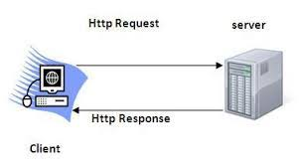

**Basic Features**

**HTTP is connectionless:**  The HTTP client, i.e., a browser initiates an HTTP request and after a request is made, the client waits for the response. The server processes the request and sends a response back after which client disconnect the connection. So client and server know about each other during current request and response only. Further requests are made on new connection like client and server are new to each other.

**HTTP is media independent:** It means, any type of data can be sent by HTTP as long as both the client and the server know how to handle the data content.

**HTTP is stateless:** A stateless protocol does not require the server to retain information or status about each user for the duration of multiple requests.

**Request types in HTTP**

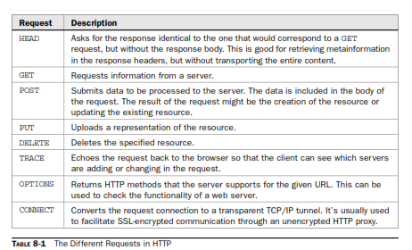

**XMPP:**

The Extensible Messaging and Presence Protocol (XMPP)

XMPP is a open source protocols

It is also known as jabber/xmpp

XMPP was originally developed in the instant messages services.

SOAP and other HTTP-based protocols—are all one-way information exchanges.

XMPP allows for two-way communication and eliminates polling.

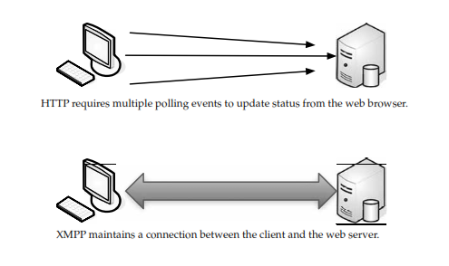

Customers:

Google, Apple, AOL, IBM, and Live Journal

XMPP offers several key advantages over such services:

**Open** — the XMPP protocols are free, open, public, and easily understandable

**Standard** — the [Internet Engineering Task Force (IETF)](http://www.ietf.org/)

**Proven -** there are tens of thousands of XMPP servers running on the Internet today, and millions of people use XMPP for instant messaging through public services such as [Google Talk](http://talk.google.com/) and XMPP deployments at organizations worldwide.

**Decentralized** — the architecture of the XMPP network is similar to email; as a result, anyone can run their own XMPP server, enabling individuals and organizations to take control of their communications experience.

**Secure** – It follows end to end encryption techniques.

**Extensible** — using the power of XML, anyone can build custom functionality on top of the core protocols

**Diverse** — a wide range of companies and open-source projects use XMPP to build and deploy real-time applications and services

### Disadvantages of XMPP

• The main disadvantage of XMPP is the redundancy of the transmitted data. Around 60% of all information transmitted by the protocol is the presence data, which creates the excess traffic.

**Secure Sockets Layer (SSL)**

SSL is the standard security technology for establishing an encrypted link between a web server and browser. This ensures that data passed between the browser and the web server stays private.